**Test 2 Questions 2020**

3. Calculate the force exerted by a biceps muscle when lifting a 3.00 kg mass. Assume the biceps muscle is

attached 40.0 mm from the elbow joint and acts at right angles to the bone. The lower arm has a mass of 1.70 kg

and is considered uniform.

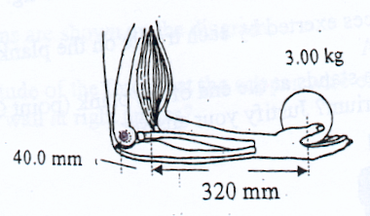

2. Mars has the following characteristics.

Mass: 6.37 x 1023 kg Radius: 3.43 x 106 m Period of rotation: 8.85 x 104 s

It can be considered perfectly spherical in shape.

Scientists in America have spent years studying the atmosphere and geology of this planet, with a view to going there one day. Assume an astronaut of 80.0 kg, carrying a combined mass for his suit of 235 kg, is on the surface.

(a) Calculate the ***apparent weight*** of the astronaut if he is standing on the equator.

(Hint: Remember that the planet is spinning.)

(4)

(b) How would this value change if the calculation were done at one of the geographical poles of

the spin axis? Explain your answer using a calculation.

(2)

(c) What ***period of rotation*** is required for the astronaut to be "flung off" the surface of Mars at the equator?

(3)

3. The moon Io is seen to revolve around Jupiter in a time of 18.6 hours at a radius of orbit measured to

be 3.65 x 105 km. Io has a mass of 3.90 x 1022 kg.

(a) Use this information to calculate the mass of Jupiter.

(4)

(b) A probe sent to scan Io orbits at a height of 1.10 x 102 km above its surface in a pole-to-pole

direction. The mass of the probe is 589 kg. Io has a mass of 3.90 x 1022 kg and a radius of

5.30 x 106 m.

(i) Determine the acceleration due to gravity acting on the probe.

(3)

(ii) Calculate the ***total energy*** of the probe as it orbits at this height above the moon.

(4)

(c) Unfortunately the probe encounters a severe micrometeor shower that knocks it into an

elliptical orbit. Describe the changes in energy as the probe maintains this orbit. You may wish

to label the diagram below.

(2)

1. Drawn below is a vase used to hold flowers in the local church. The people supplying flowers have decided to place very long stemmed proteas into the vase for the Sunday service. Proteas have a very heavy head and a representation of one is drawn below.

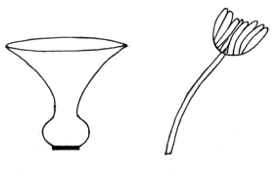

(a) Describe how 6 - 8 flowers should be arranged in order to make the combination stable.

A simple drawing may be helpful. Assume no water is used in the vase.

(1)

(b) Does the addition of water to the vase improve its stability? Explain your answer.

(2)

(c) Explain why the vase is stable with or without water in it.

(2)

2. Cirque du Soleil travel the world performing under a Big Top. The performers and crew alike assist in erecting the structure around several large poles. The diagram below shows how a pole is raised.

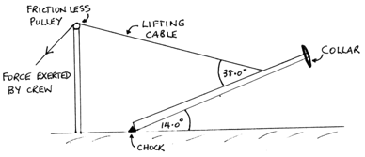

The pole is not uniform and has a mass of 3.20 x 102 kg. Its centre of mass is 4.20 m from the bottom. The collar at the top is 90.0 kg. A chock is used to stop the pole sliding across the ground as it is raised. The lifting cable is attached 3.00 m from the top and the pole forms a 14.0 ° to the ground at the instant shown. The pole is 10.0 m long.

(a) Calculate the tension in the lifting cable.

(3)

(b) What is the reaction force exerted by the chock onto the bottom of the pole.

(4)

3. A tightrope walker has recently been practising for a crossing of Niagara Falls by walking between two buildings in Toronto. The performer is 83.0 kg in mass and he carries a 7.50 m long pole that curves downwards to assist his balance. The walker is part of the way across the wire as shown below.

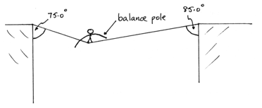

(a) Calculate the tension in each part of the wire. Ignore the mass of the wire and the pole.

(4)

(b) Give **one valid reason** why the performer uses such a long and curved pole for assisting

balance. Explain your answer.

(2)

6. The planet Jupiter orbits the Sun with a period of 4333 days. It has a mass 318 times larger than the

mass of the Earth and a diameter 11.2 times larger than the diameter of the Earth.

(a) Calculate the period of Jupiter's orbit in seconds.

(2)

(b) Assuming that Jupiter has a circular orbit with a radius of 5.20 AU (astronomical unit), where

1.00 AU is the distance from the Earth to the Sun, calculate the speed of Jupiter in orbit around

the Sun.

(3)

The orbit of Jupiter is known to be elliptical rather than circular. At Jupiter's closest point, it is

4.95 AU from the Sun and at its most distant point it is 5.46 AU from the Sun.

(c) Calculate the force of gravitational attraction between Jupiter and the Sun when Jupiter is most

distant from the Sun.

(3)

(d) Calculate the speed of Jupiter in its orbit when it is most distant from the Sun.

(3)

When it is closest to the Sun, the force of attraction between Jupiter and the Sun is 4.60 x 1023 N and

its orbital speed is 1.25 x 104 ms-1.

(e) Which one of the following statements best describes the motion and energy of Jupiter as it

orbits the Sun?

A. The kinetic energy of Jupiter does not change as it orbits the Sun.

B. The kinetic energy of Jupiter keeps increasing as it orbits the Sun.

C. The total energy of Jupiter stays the same as it orbits the Sun; the kinetic energy

increases as the gravitational potential energy decreases.

D. At its nearest point to the Sun, Jupiter has the most energy; its kinetic energy is

very big and it also has a large gravitational potential energy.

E. Gravitational potential and kinetic energy change depending on where Jupiter is in

its orbit; its potential and kinetic energy both increase as Jupiter gets closer to the

Sun.

Answer

(1)

10. This question is about the gravitational field around an asteroid. The asteroid is spherical and of

uniform density. The diagram below shows lines of equal gravitational field strength as dashed lines.

There is a constant ratio in the value of the field strength between each line.

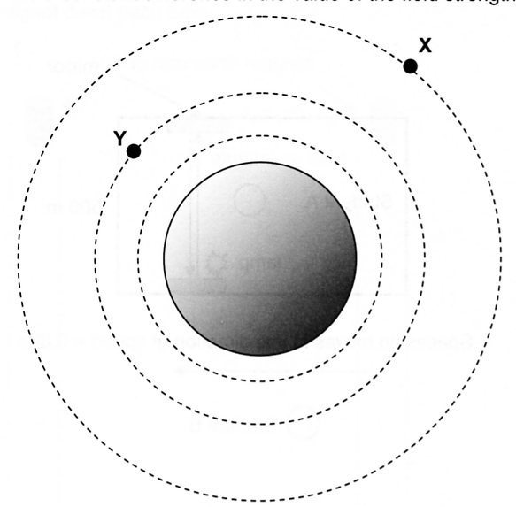

(a) Describe what the diagram shows about the gravitational field strength as the distance from the

asteroid increases.

(1)

(b) Draw vectors to represent the gravitational field at points X and Y. (2)

(c) The asteroid has a radius of 1.25 x 105 m. If the gravitational field strength on its surface is

0.194 Nkg-1, calculate the mass of the asteroid.

(3)

2. A circus performer of mass 65.0 kg is walking along a high wire. The wire sags under the weight of

the performer and makes an angle of 15.0 ° with the horizontal, as shown in the diagram. Calculate

the tension in the wire between the poles.

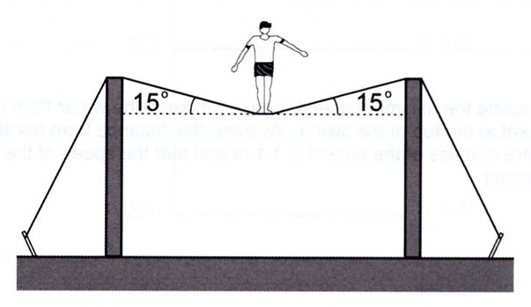

(3)

3. An empty pan has a mass of 4.50 x 102 grams without the handle. The handle has a mass of 50.0 g.

The pan is being held at the end of the handle. Assume that both the pan and handle are uniform. The

pan has 2.00 kg of water in it. The water is uniformly distributed in the pan and is not moving.

What moment should be supplied by the person holding the pan to stop it from tilting? You should

give the size and direction of this moment.

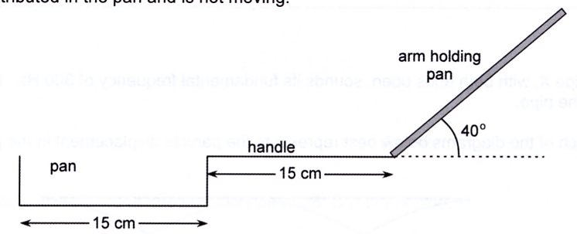

7. A concrete bridge structure is being built. It consists of vertical pillars that support horizontal

platforms.

(a) The section of bridge platform labelled PQ on the diagram below is in equilibrium. Draw and

label the forces acting on the platform.

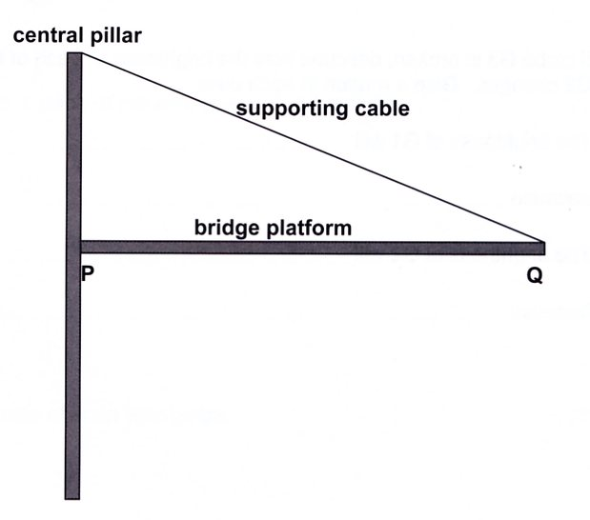

(3)

The diagram below shows a heavy truck moving along the bridge during construction. The

distances in metres from the central pillar are shown on the diagram. The centre of mass of the

truck is at the 10.0 m mark and the bridge platform extends to 35.0 m from the pillar, the top of

which is 17.5 m above the platform. The section of bridge platform shown has a mass of

4.20 x 102 tonnes and the truck has a mass of 50.0 tonnes.

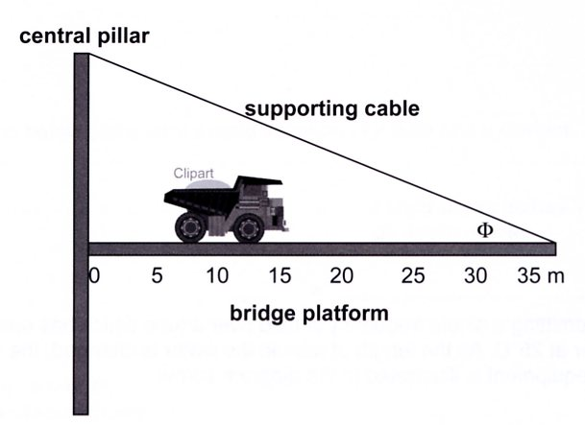

P

Q

(b) Calculate the angle 

(1)

(c) By taking moments about a suitable point calculate the tension in the cable.

(3)

(d) Calculate the force exerted at point P by the central pillar onto the bridge when the truck is at

the position shown.

(3)

8. A springboard diver with a mass of 62.5 kg is standing on the end of a diving board as shown below.

The springboard has a mass of 1.20 x 102 kg. A clamp at C holds the end of the board in place.

Assume for parts (a) and (b) only that the springboard is uniform and rigid ( i.e. does not bend).

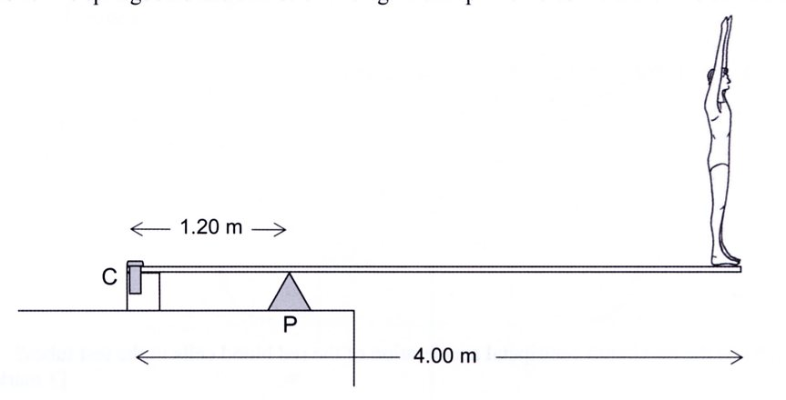

(a) On the diagram, use arrows to show the direction of the forces on the board due to the pivot

point (P) and the clamp (C).

(2)

(b) Calculate the forces acting on the clamp (C) and the pivot point (P) when the diver is standing

on the end of the board .

(4)

9. A support for a hanging pot plant consists of a 0.500 m long uniform rigid boom AD of mass

0.750 kg pivoted at the lower end and supported by a light rope to the wall as shown in the figure below. The angles are as shown.

The angles ABC and BAC are 45.0˚ and 60.0˚ respectively and the support cable BC is connected to

the mid-point of AD at C. The mass of the pot plant and basket is 2.20 kg.

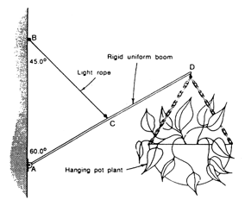

(a) Calculate the tension in the rope.

(3)

(b) Calculate the magnitude and direction of the force exerted by the wall on the boom at the

point A.

(3)